CS-010 CF Grounding & Electrical Bonding
Doc ID | CS-010
Title | CF Grounding & Electrical Bonding
Revision | D
Status | Draft, pending Lead signature
Effective date | 2026-10-10
Supersedes | Tribal grounding knowledge from SN5 trials

Approvals
Role | Name | Date
Author | Simon Starbuck (drafted with Claude, SN6 Resources) | 2026-07-12
Reviewer | simon (reviewer agent) | 2026-10-10
Approver (Composites Lead)

Revision history
Rev | Date | Author | Description of change
A | 2026-07-12 | Claude | Initial issue, encodes the diffuser-validated method + the catch-can decision lesson
B | 2026-07-28 | Claude | Language pass: fewer em dashes for rhythm variety, no content change.
C | 2026-08-28 | Claude | Engineering pass (CS-000 Rev C conventions). Figure 1 draws the diffuser recipe in plan: mesh sheets, the 25 mm overlap, the terminable tail, and the probe pattern that proves the part. One intensifier cut from §1. No rule changed.
D | 2026-10-10 | Claude (doc overhaul, requested by Simon Starbuck) | The criterion and the path decision now point at places that exist in the app (a "grounding resistance" Quality row, the "Stack frozen" note, the Other technique for retrofits and cross-team requests); §8 named a decision-point field that does not exist. Surface paths (strip, braid, tape, paint) added as a third branch because SN6 is reaching for them, each proven on a first article; only permeable mesh goes in an infused stack. The probe table goes in the measuring step's note and a failed point is a ⚑ issue. WO-SN5-006 and WO-SN5-026 named as reference and counter-example. Copper mesh spec marked not recorded. Emphasis bold removed. §6 adds PPE for graphite powder (respirator with P100 and nitrile gloves while weighing and mixing) and gloves for cut copper mesh, as requirements because the shop stocks both (Simon, 2026-10-10). The measuring step is named for every run type. Header title matches the H1 (R-IDX-04). Register R-010-01..08 and R-010-30 (§1 no longer claims the catch can was solved). Graphite powder now gives the SN5 trial value (about 5 wt%) in place of an unsourced 1-5 wt%.

1. Purpose
EV rules want conductive parts near HV/chassis grounded (our SN5 working criterion: <5 Ω to the grounding point). SN5 gave us both the success story and the cautionary tale. The diffuser (target and method written down up front, copper mesh in the stack) validated at <1 Ω continuous everywhere (2026-06-21) and drew praise from the design judges at comp. The catch can had no written criterion; its method was improvised for six months (Nov→May) and never hit target with CF wrapping, so the team gave up on CF for that geometry and pivoted to epoxy + copper paths (PP-05). WO-SN5-026 records no passing measurement after the pivot. This doc exists so we repeat the first one.

2. Scope
Any CF part with a grounding/bonding requirement, and any conductive-path retrofit on existing parts. The Ω target and rule interpretation come from the EV rules owner (powertrain/rules lead); this standard covers how composites achieves and proves the target, not what the target legally is.
Requests from other subteams (cooling, brakes, aero) arrive as a work order with the Other technique. The Ω and distance targets on them stay the rules owner's numbers.

3. References
Ref | Document | Where
R1 | PP-05 RCA (catch-can saga) | FEB-COMP-PP-001
R2 | CS-002 (mesh in the ply table) | CS-002 §7.1
R3 | SN5 grounding trials: graphite powder judged likely insufficient alone vs copper mesh (Nico Ortiz, #composites, 2025-11-03); graphite-in-resin layups at a little over 5 wt% (#composites, 2026-01-24 to 2026-01-28) | Slack record
R4 | Diffuser validation <1 Ω (post-comp recap) | #composites, 2026-06-21
R5 | WO-SN5-006, UT diffuser: the reference part (Quality row "grounding resistance", target <5 Ω every probe point, actual <1 Ω continuous everywhere) | App, Work Orders
R6 | WO-SN5-026, catch can (grounding retrofit): the counter-example (about 40 Ω outer CF to can end on 2026-05-25, against <5 Ω needed) | App, Work Orders
R7 | SN6 surface-path proposals: copper tape wrap (#cooling, ts 1789966817.624499); copper paint as a lighter alternative to heavy mesh, and a non-permeable layer blocking resin in the layup (#composites, ts 1791231472.229019, 1791248106.544919) | Slack record

4. Definitions
- Grounding point: the fastener/tab where the part's conductive path meets chassis ground.
- Probe pattern: the defined set of surface points measured against the grounding point.
- CF as conductor: carbon laminate conducts, but through-thickness resistance through resin-rich layers is high and unpredictable; bare CF also can't be reliably terminated. Hence copper mesh.
- Surface path: a conductor applied to the cured part's surface: copper strip or braid bonded with epoxy, copper tape, or conductive paint.

5. Equipment & Materials
Item | Spec / product | Source | Notes
Copper mesh | Fine woven copper mesh (repeat team buy). Wire size and opening not recorded; read them off the package | Amazon | The validated conductor (R3, R4). Name the ply "copper mesh" in the stack (§7.2 step 1)
Multimeter | 2-wire, known-good leads | Electrical | Zero the leads first (touch together, note offset)
Ring terminals / grounding hardware | Per part design | McMaster
Graphite powder | About 5 wt% in resin (team value: the SN5 trial, R3) | Sigma-Aldrich | Secondary/supplement only; insufficient alone (R3)

6. Safety
Grounding verification happens on or near the car: follow EV safety rules. No probing near energized HV; HV isolation confirmed by the ESO before resistance measurements on installed parts. Bench measurements on loose parts: no special hazards beyond CS-009 dust rules if sanding contact points.
Graphite powder (§5, §7.2 step 4): wear the respirator with a P100 cartridge and nitrile gloves while weighing and mixing it. The shop stocks A + P100 cartridges and nitrile gloves (inventory.js restock table). No graphite SDS is on file yet. Cut copper mesh has sharp wire ends: wear gloves when cutting and placing it.

7. Procedure

7.1 Decision point first (the catch-can lesson)
- Before any layup work, decide whether CF with copper mesh is the right conductive path for this geometry. Write the answer and a one-line why in the note on "Stack frozen". A retrofit or a cross-team grounding job is created with the Other technique, and the answer goes in the note on "Define acceptance criterion: target and method, set before work starts", the step that blocks everything after it.
- Good fit: large open laminates (diffuser, panels) where mesh lays flat in the stack and terminates at accessible flange points.
- Bad fit: thin-walled, tapered, or wrapped metal substrates (the catch can: sanding punctured the can wall at the taper; through-thickness contact never stabilized). For these, use a surface path, or reconsider whether the part needs CF at all.
- Surface path: copper strip or braid bonded with epoxy, copper tape, or conductive paint, applied after cure. Weigh mass as well as geometry: mesh in the stack is heavy on a large part like the undertray (R7).
- Write the acceptance criterion before work starts: Ω target, probe pattern (grid spacing or named points), and measurement method (7.3). On the run, add a Quality row ("+ check" in edit mode) with Criterion "grounding resistance" and fill its Target when the run is created. On an Other run, write the same criterion in the note on "Define acceptance criterion: target and method, set before work starts". Six months of drift happened because none of this was written (R1).
- A conductive path this team has not yet proven is proven on a first article by the §7.3 method before any part depends on it.
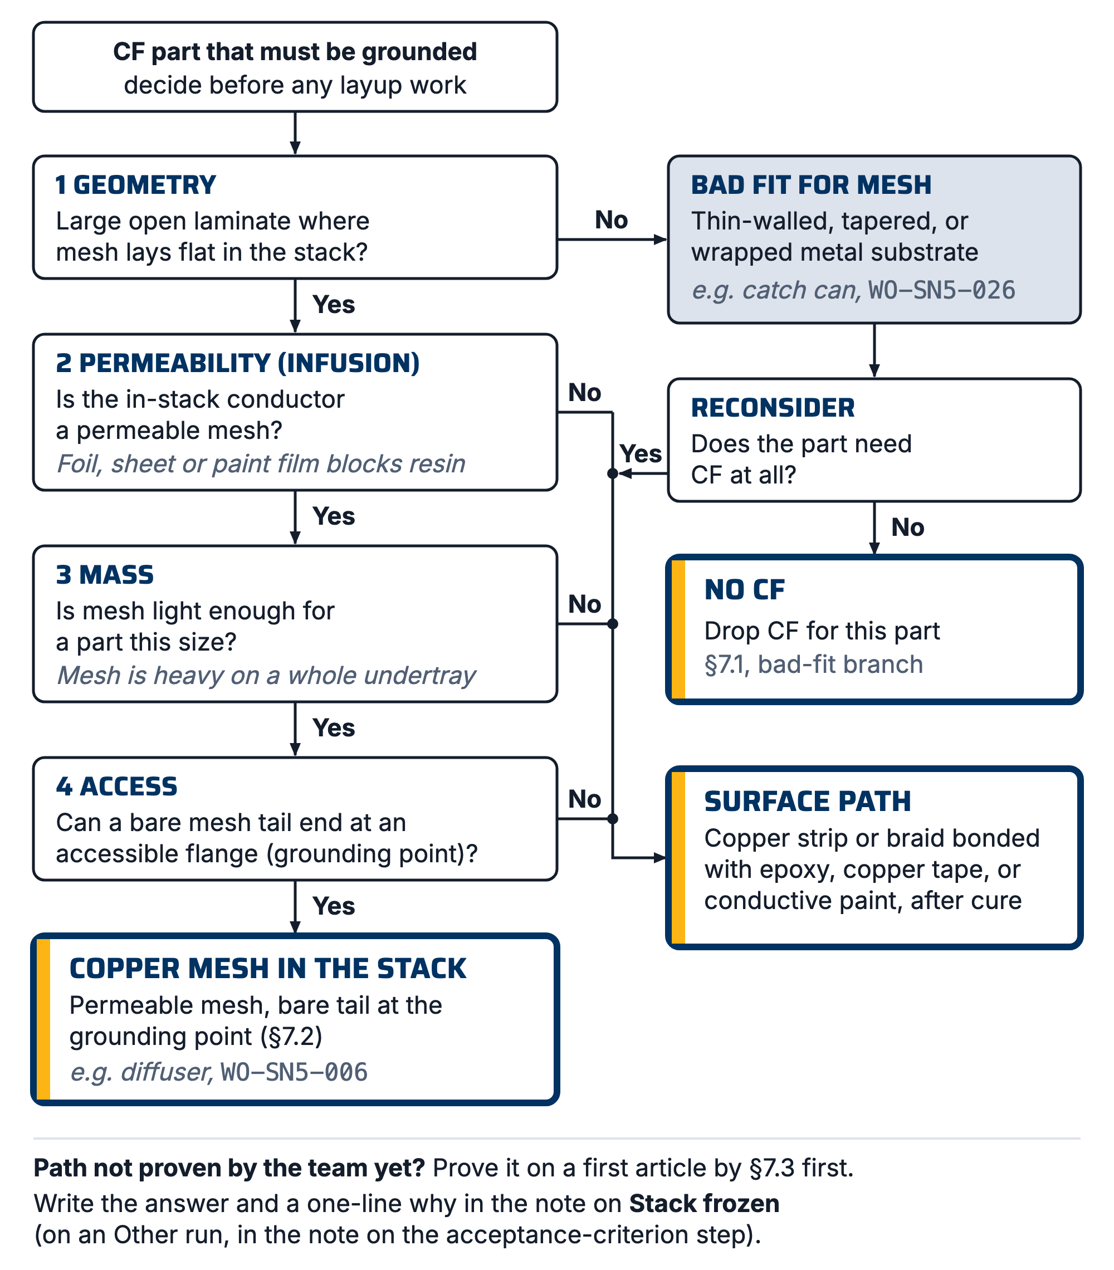
Figure 1. Choosing the conductive path: mesh in the stack, a surface path, or no CF, decided by geometry, permeability in an infusion, mass, and access to the grounding point.

7.2 Build the path (mesh-in-stack method: the diffuser recipe)
- Put copper mesh in the ply table per CS-002: mesh layer(s) positioned to be continuous from part surface zones to the grounding point(s), 25 mm minimum overlap (team value) where mesh sheets meet. Name the ply's material "copper mesh" so the stack view tags it Mesh. Only permeable mesh shall go in an infused stack: foil, solid sheet or a paint film blocks resin flow (R7).
- Mesh must reach the grounding point as bare, terminable material: leave a mesh tail at the flange/fastener location, protected during infusion (peel-ply window or masked zone).
- For surfaces needing exposed conductivity, an 88-gsm outer ply over mesh keeps finish while staying thin; validate on the first article that surface-to-ground still passes.
- Graphite powder (about 5 wt% in the resin, the SN5 trial value, R3; team value) may be added as a supplement in zones where mesh coverage is marginal, never as the primary path (SN5 trials judged it insufficient alone, R3). If used, record wt% on the WO.
- Infuse/laminate per CS-006/CS-007. Note on the WO where mesh actually ended up (as-built).
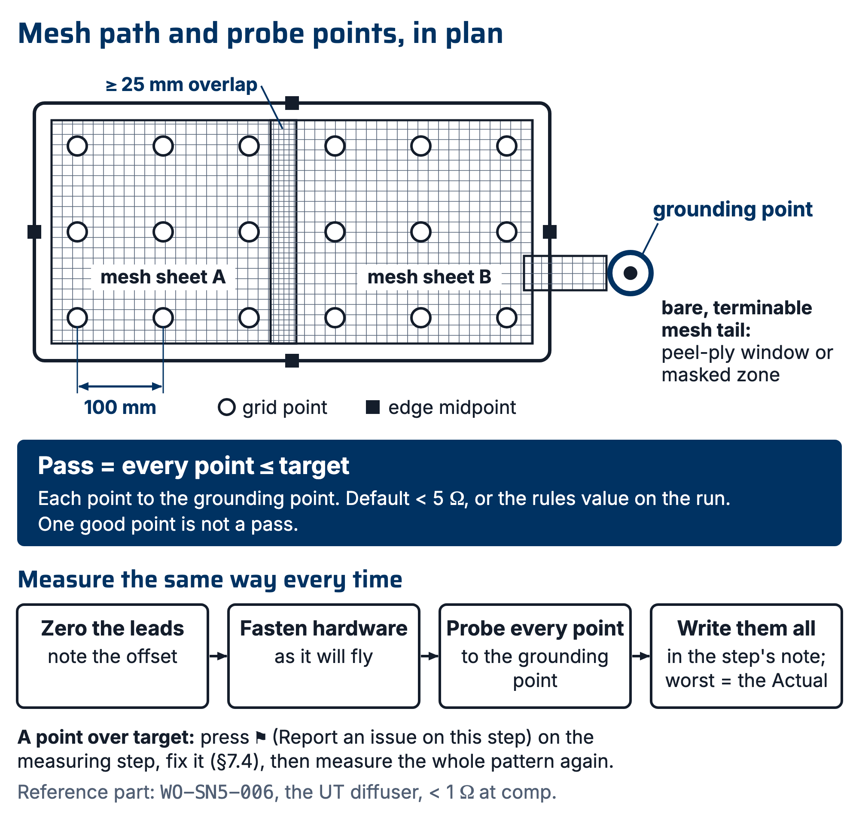
Figure 2. The mesh-in-stack path in plan: sheets overlapping ≥25 mm, a bare terminable tail at the grounding point, and the default probe pattern (100 mm grid plus edge midpoints). Every point measures to the grounding point; every point passes or the part does not.

[ PHOTO: copper mesh tail at grounding point before bagging ]

7.3 Measure: one method, every time
- Zero the multimeter leads; record lead resistance.
- Fasten the grounding hardware as it will fly (torqued, washers as designed); hand-held contact readings are noise.
- Probe every point in the run's probe pattern (default: 100 mm grid over conductive zones + every edge midpoint) to the grounding point. Record each value minus lead offset as a table in the note of the measuring step ("Trim and finish" on Mold infusion, Mold wet lay and Foam wrapped runs; "Finish" on a Glass infusion run; "Verify against criterion" on an Other run). Write the worst reading as the Actual on the "grounding resistance" Quality row.
- Pass = every point ≤ target (default <5 Ω, or the rules value on the run). Not "one good point": that question was still open in May 2026, six months in (R1). A point over target is an issue: press ⚑ (Report an issue on this step) on the measuring step, and fix it per §7.4 before it is disposed.

7.4 If it fails
- Map the failing zone; usually a mesh discontinuity or resin-isolated overlap.
- Fixes in order of preference: expose + bond a copper strip bridge (epoxy + copper path), add an external ground tab at the failing zone, or lightly abrade to mesh at a termination point and re-terminate. Do not sand thin laminates chasing contact. That is how the catch cans died (R1).
- Re-measure the full pattern after any fix, not just the failed point.

8. Quality checks / acceptance criteria
Check | Target | Method | Record where
Criterion written before work | Ω target + probe pattern + method | Quality row "grounding resistance" with its Target filled when the run is created; on an Other run, also the note on "Define acceptance criterion: target and method, set before work starts" (a blocker) | Run
Decision point answered | Mesh in the stack, a surface path, or no CF, with a one-line why | Note on "Stack frozen"; on an Other run, the note on the criterion step | Run
Resistance | Every probe point ≤ target | §7.3 method | Full probe table in the measuring step's note; worst reading as the Actual on the Quality row; any point over target a ⚑ issue on that step
As-built mesh record | Matches or deviations noted | CS-002 §7.4 | WO

9. Records
The run keeps: the path decision and its one-line why (the "Stack frozen" note, or the criterion step's note on an Other run), the criterion (the "grounding resistance" Quality row), the full probe-reading table (values, not "pass") in the measuring step's note, photos of mesh placement and termination, and any retrofit fixes with their ⚑ issues.
WO-SN5-006 (UT diffuser) is the reference part: target set up front, method recorded, <1 Ω at comp on 2026-06-21 (R4, R5). Its record holds that summary only, not a probe table; the first SN6 grounded part will hold the first full one. WO-SN5-026 (catch can, about 40 Ω on 2026-05-25 against <5 Ω needed) is the counter-example (R6).

